SOFTWARE ENGINEERING
Chapter 5: Project Management

Chapter 5: Project Management

1. Learning Objectives
After studying this chapter, you should be able to:
- Explain the main tasks done by project managers.
- Understand what software project management is and why it is different from other engineering management.
- Discuss project planning and the planning process.
- Use graphical schedule representations such as bar charts and activity networks.
- Identify different types of risks and explain the risk management process.

2. Topics Covered
# | Topic
1 | Management Activities
2 | Project Planning
3 | Project Scheduling
4 | Risk Management
5 | System Reliability Specification (Bonus Topic)

Section 1: Software Project Management

1.1 What Is Software Project Management?
Software project management is the process of ensuring that software is delivered:
- On time (within the agreed schedule)
- Within budget (without exceeding costs)
- In accordance with requirements (meeting what the customer needs)

Project management is needed because software development always has budget and schedule constraints set by the organisation.

1.2 Software Management Distinctions
Software projects are different from other engineering projects. Here are the key reasons:
Distinction | Explanation
The product is intangible | Software cannot be seen or touched like a bridge or a machine. This makes it hard to measure progress.
The product is uniquely flexible | Software can be changed easily at any stage. This often leads to scope changes that affect schedule and cost.
Not a recognized discipline | Software engineering does not yet have the same formal status as mechanical or electrical engineering.
No standard process | Different organisations use different development processes. There is no single agreed standard.
Many projects are one-off | Most software projects are unique. There is little prior experience to rely on for estimation.

Memory Tip: To remember distinctions: use the phrase 'I F N S O' — Intangible, Flexible, Not standard, Standardless process, One-off.

1.3 Management Activities
A software project manager performs many activities throughout the project lifecycle:
Activity | Description
Proposal writing | Writing a document to convince the client or management to approve the project.
Project planning and scheduling | Breaking the project into tasks, estimating time, assigning people, and setting deadlines.
Project costing | Estimating how much the project will cost in staff, hardware, and other resources.
Project monitoring and reviews | Regularly checking that the project is on track and holding review meetings.
Personnel selection and evaluation | Choosing the right people for the team and reviewing their performance.
Report writing and presentations | Producing progress reports and presenting project status to stakeholders.

1.4 Management Commonalities
These activities are not unique to software. Many engineering projects share the same management challenges:
- Technically complex engineering systems often suffer the same problems as software systems.
- Techniques from general engineering project management can be applied to software projects.

1.5 Project Staffing
Selecting the ideal team is often difficult. Common staffing constraints include:
- The project budget may not allow highly paid experts.
- Staff with the right experience may not be available.
- The organisation may want to use the project to develop employee skills.

Note: Managers must work within these constraints, especially when there is a shortage of trained staff.

EXAM-ORIENTED NOTES
Short Questions
1. What is software project management?
2. List any three management activities performed by a project manager.
3. Why is software management different from other engineering management?
4. What is meant by saying that software is 'intangible'?
5. Why is project staffing challenging in software development?
Long Questions
1. Explain the five main distinctions of software project management with examples.
2. Discuss the role of a project manager in a software development project. Include planning, staffing, and monitoring.
Viva / Interview Questions
1. Why can software not be measured the same way as a physical product?
2. How does the flexibility of software cause problems for project management?
3. What are the consequences of adding untrained staff to a software project?

Section 2: Project Planning

2.1 What Is Project Planning?
Project planning is probably the most time-consuming project management activity.
- It starts at the very beginning (initial concept) and continues until the system is delivered.
- Plans must be regularly revised as new information becomes available.
- Various types of plans support the main project plan.

2.2 Types of Project Plan
A software project may require several types of plan. The table below summarises these:
Plan Type | Description
Quality plan | Describes the quality procedures and standards that will be used in the project.
Validation plan | Describes the approach, resources, and schedule for system validation.
Configuration management plan | Describes the procedures and structures for configuration management.
Maintenance plan | Predicts the maintenance requirements, costs, and effort for the system.
Staff development plan | Describes how the skills and experience of team members will be developed.

Note: The main project plan covers schedule and budget. All other plans support it.

2.3 The Project Planning Process
Project planning is a continuous loop. The process involves:
- Establish the project constraints.
- Make initial assessments of project parameters (size, complexity, budget).
- Define project milestones and deliverables.
- Draw up the project schedule.
- Initiate activities according to the schedule.
- Wait and observe progress.
- Review project progress and revise estimates.
- Update the project schedule.
- Re-negotiate constraints and deliverables if needed.
- If problems arise: initiate a technical review and possible revision.
- Repeat from step 4 until the project is complete or cancelled.

Memory Tip: Think of planning as a loop: Plan → Act → Review → Revise → Repeat.

2.4 The Project Plan Document
The project plan sets out three key things:
- The resources available to the project (people, tools, budget).
- The work breakdown (what tasks need to be done).
- A schedule for the work (when each task will be done).

2.5 Project Plan Structure
A complete project plan document contains the following sections:
Section | Content
Introduction | Brief overview of the project scope and objectives.
Project organisation | How the team is structured and who is responsible for what.
Risk analysis | Identification of risks and plans to manage them.
Hardware and software resource requirements | Tools, equipment, and licenses needed.
Work breakdown | Detailed list of tasks and sub-tasks.
Project schedule | Timeline showing when each task will be done.
Monitoring and reporting mechanisms | How progress will be tracked and reported.

2.6 Activity Organisation: Milestones and Deliverables
Activities in a project must be organised to produce measurable outputs:

Milestone | The end-point of a process activity. It is a specific, measurable point that shows a task is complete.
Example | Completing the requirements specification document is a milestone.

Deliverable | A project result that is delivered to the customer. It is something the customer receives.
Example | The final tested software system delivered to the client.

Note: Milestones are for internal management. Deliverables are for the customer.

The waterfall model makes it easy to define milestones because each phase has a clear end-point.

2.7 Milestones in the Requirements Engineering (RE) Process
The diagram below shows the activities and milestones in the requirements engineering process:

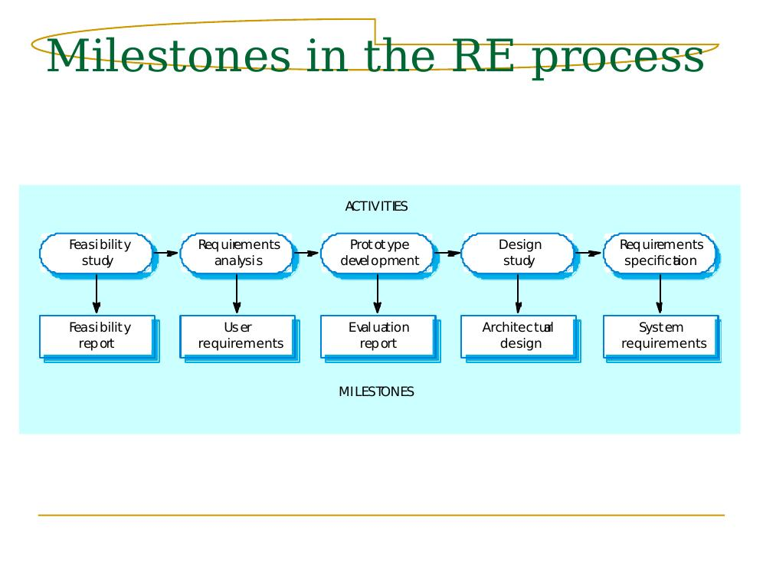
Figure 5.1: Milestones in the Requirements Engineering Process
Explanation: The top row (cloud shapes) shows the ACTIVITIES. The bottom row (boxes) shows the MILESTONES (outputs). Each activity produces a document or result that managers can evaluate.
Activity | Milestone / Output
Feasibility study | Feasibility report
Requirements analysis | User requirements document
Prototype development | Evaluation report
Design study | Architectural design document
Requirements specification | System requirements document

EXAM-ORIENTED NOTES
Short Questions
1. What is project planning?
2. Define milestone and deliverable. How are they different?
3. List five sections of a project plan document.
4. Why is project planning a continuous process?
5. What types of plan support the main project plan?
Long Questions
1. Describe the project planning process as a loop. Include all steps and explain why each step is important.
2. Explain the milestones in the requirements engineering process with the help of a diagram.
Viva / Interview Questions
1. What is the difference between a milestone and a deliverable?
2. Why must project plans be regularly revised?
3. What is the purpose of a validation plan?

Section 3: Project Scheduling

3.1 What Is Project Scheduling?
Project scheduling means deciding:
- What tasks need to be done.
- How long each task will take.
- What resources are needed for each task.
- The order in which tasks should be completed.

Good scheduling also means:
- Organising tasks concurrently (in parallel) to make the best use of the team.
- Minimising task dependencies so one delayed task does not delay the whole project.

Note: Project scheduling is heavily dependent on the manager's intuition and past experience.

3.2 The Project Scheduling Process
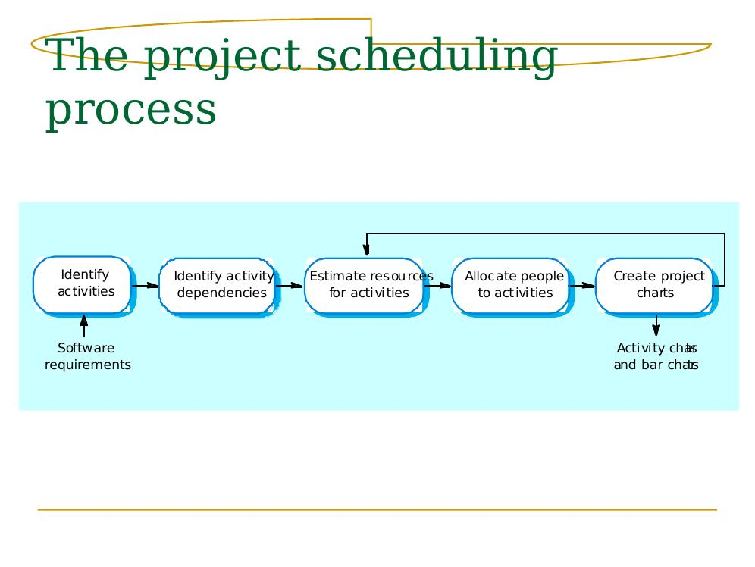
Figure 5.2: The Project Scheduling Process
Explanation: The scheduling process is a sequence of 5 steps shown in the diagram above:
Step | Action | Output
1 | Identify activities | List of tasks derived from software requirements.
2 | Identify activity dependencies | Understanding of which tasks must wait for others.
3 | Estimate resources for activities | Time and people needed for each task.
4 | Allocate people to activities | Each team member assigned to specific tasks.
5 | Create project charts | Activity charts and bar charts for the schedule.

3.3 Scheduling Problems
Project scheduling is difficult because of several common problems:
Problem | Explanation
Difficulty of estimation | It is hard to know how long a task will take before it starts. Developers often underestimate.
Productivity is not proportional to people | Doubling the team does not double the speed. More people means more communication overhead.
Adding people to a late project makes it later | New people need time to learn. They slow down experienced developers who must teach them.
The unexpected always happens | Hardware failures, staff illness, changing requirements — always plan for the unexpected.

Note: Brooks's Law: Adding manpower to a late software project makes it later. (Fred Brooks, 'The Mythical Man-Month')
Memory Tip: Remember PEPA: Productivity, Estimation, People, And-the-unexpected — the four scheduling problems.

3.4 Bar Charts and Activity Networks
Two graphical tools are used to represent the project schedule:

Activity Network | A diagram that shows all project tasks, the dependencies between them, and the critical path.
Example | An arrow from Task A to Task B means Task B cannot start until Task A is complete.

Bar Chart (Gantt Chart) | A horizontal bar chart that shows tasks on the vertical axis and calendar time on the horizontal axis.
Example | A bar from Week 2 to Week 5 for 'Design' means the design phase takes 3 weeks.

3.5 Task Durations and Dependencies
Tasks in a project have specific durations and dependencies. The table below shows an example set of tasks:
Task | Duration | Depends On
T1 – Requirements analysis | 8 weeks | None
T2 – Architecture design | 7 weeks | T1
T3 – Interface design | 3 weeks | T1
T4 – Database design | 4 weeks | T2
T5 – Subsystem development | 10 weeks | T2, T3
T6 – System integration | 3 weeks | T4, T5
T7 – Acceptance testing | 4 weeks | T6
T8 – Documentation | 5 weeks | T5

Note: Tasks should not be too small. Aim for tasks that take about 1–2 weeks.

3.6 Activity Network (Critical Path)
An activity network shows the sequence and dependencies of all tasks. The critical path is the longest sequence of dependent tasks. Any delay to a critical path task delays the whole project.

Example Activity Network (text representation):
Activity Network — Dependencies and Critical Path
T1 (8w) ─→ T2 (7w) ─→ T4 (4w) ─┐
T1 (8w) ─→ T3 (3w) ─┐ ├─→ T6 (3w) ─→ T7 (4w) ← CRITICAL PATH
└─→ T5 (10w)─┘
T5 (10w) ─→ T8 (5w) [not on critical path for T7]
Critical Path: T1 → T2 → T5 → T6 → T7 = 8+7+10+3+4 = 32 weeks minimum

3.7 Activity Timeline (Bar Chart / Gantt Chart)
A bar chart shows the project schedule laid out against calendar time. Each task is shown as a horizontal bar. Parallel bars show tasks done at the same time.

Example timeline (simplified representation):
Task | Weeks 1-4 | Weeks 5-8 | Weeks 9-12 | Weeks 13-16 | Weeks 17-20
T1 Requirements | ████████
T2 Architecture |  | ████████████
T3 Interface |  | ████
T4 Database |  |  | ████████
T5 Subsystem Dev |  |  | ████████████████
T6 Integration |  |  |  | ████████
T7 Acceptance Test |  |  |  |  | ████████
T8 Documentation |  |  |  | ████████████

3.8 Staff Allocation Chart
A staff allocation chart shows which team members are assigned to which tasks during which time periods. This helps managers ensure no one is over-allocated or idle.

Example staff allocation (simplified):
Staff Member | T1 | T2 | T3 | T4 | T5 | T6 | T7
Analyst A | Yes
Designer B |  | Yes | Yes
Developer C |  |  |  | Yes | Yes
Developer D |  |  |  |  | Yes | Yes
Tester E |  |  |  |  |  |  | Yes

EXAM-ORIENTED NOTES
Short Questions
1. What is project scheduling?
2. What is the difference between a bar chart and an activity network?
3. What is meant by 'critical path' in a project?
4. Why does adding staff to a late project make it later?
5. What are the four common scheduling problems?
Long Questions
1. Describe the project scheduling process with the help of a diagram. Explain all five steps.
2. Explain the use of bar charts and activity networks in project scheduling. Give an example of each.
Viva / Interview Questions
1. What is Brooks's Law? Give a practical example.
2. Why should tasks in a project be approximately 1–2 weeks in duration?
3. How does task dependency affect the project schedule?

Section 4: Risk Management

4.1 What Is Risk Management?
Risk management involves identifying possible problems (risks) and making plans to reduce their effect on a project.

Risk | A probability that some adverse (negative) event will occur that could harm the project.
Example | There is a 30% chance that a key developer may leave the project midway.

There are three types of risk:
Risk Type | Definition | Example
Project risks | Affect the schedule or resources of the project. | Staff leaving, equipment failure, budget cuts.
Product risks | Affect the quality or performance of the software. | Reused components have defects, performance requirements not met.
Business risks | Affect the organisation developing or buying the software. | A competitor releases a better product first.

4.2 The Risk Management Process
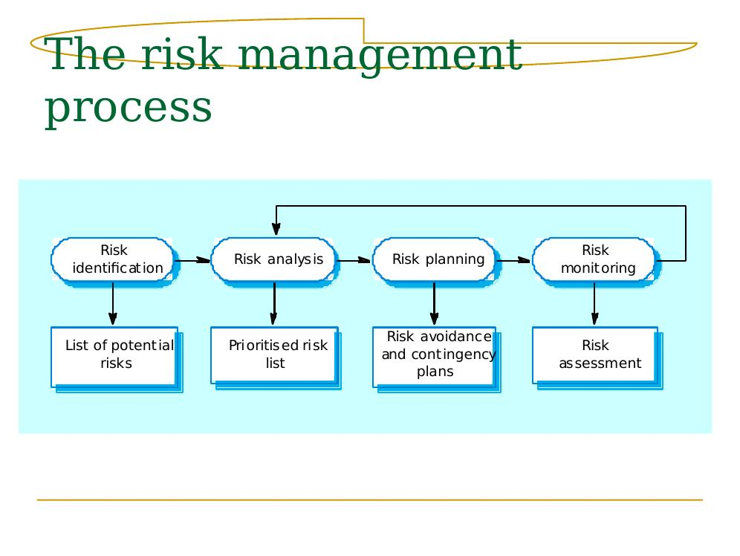
Figure 5.3: The Risk Management Process
Explanation: The diagram shows 4 stages forming a loop. The feedback arrow at the top shows that monitoring can trigger re-identification of risks.
Stage | Description | Output
Risk identification | Find all possible project, product, and business risks. | List of potential risks
Risk analysis | Assess the likelihood and seriousness of each risk. | Prioritised risk list
Risk planning | Create strategies to avoid or minimise each risk. | Risk avoidance and contingency plans
Risk monitoring | Regularly check whether risks are increasing or decreasing. | Risk assessment reports

4.3 Risk Identification
Risks are identified by category. The five key categories are:
Category | Description | Example Risk
Technology risks | Risks from the technology used in the project. | The database may not handle the required transaction volume.
People risks | Risks related to the project team. | Key developer may leave; experienced staff unavailable.
Organisational risks | Risks from the organisation managing the project. | Management restructuring may reduce project priority.
Requirements risks | Risks related to changing or unclear requirements. | Customer keeps changing requirements after design is done.
Estimation risks | Risks from inaccurate estimates of size or effort. | Development time was underestimated by 50%.

4.4 Risks and Risk Types — Example Table
The following table gives real examples of software risks, categorised by type:
Risk | Type | Description
Staff turnover | Project | Experienced staff leave and take knowledge with them.
Management change | Project | New management may cancel or deprioritise the project.
Hardware unavailability | Project | Hardware for development or deployment is delayed.
Requirements change | Project/Product | Requirements keep changing, requiring rework.
Technology underperformance | Product | Technology does not perform as expected.
Product size larger than estimated | Product | Software takes longer to build than planned.
CASE tool underperformance | Product | Development tools do not work as well as expected.
Financial problems | Business | Funding for the project is cut.
Product competition | Business | A competitor releases a similar product.

4.5 Risk Analysis
For each identified risk, two things are assessed:
- Probability: How likely is it that the risk will occur?
- Effect (Seriousness): How bad will the consequences be if it occurs?

Probability levels:
Probability Level | Meaning
Very low | Less than 10% chance
Low | 10–25% chance
Moderate | 25–50% chance
High | 50–75% chance
Very high | Greater than 75% chance

Effect levels:
Effect Level | Meaning
Catastrophic | Could completely destroy the project or cause serious harm.
Serious | Would require major rescheduling or additional resources.
Tolerable | Would cause some delay but can be managed.
Insignificant | Would have very little effect on the project.

4.6 Risk Analysis Example Tables
Table (i): Risk probability and effect ratings for common risks:
Risk | Probability | Effect
Organisational financial problems | Low | Catastrophic
Recruitment difficulties | High | Serious
Staff illness | Moderate | Serious
Defective components | Moderate | Serious
Component performance shortfalls | Moderate | Serious
Requirements changes | High | Serious
Technology changes | Very low | Catastrophic
Product underperformance | Moderate | Serious

Table (ii): Risks prioritised by the combination of probability and effect:
Priority | Risk | Reason
1 (Highest) | Technology changes | Although probability is very low, the effect is catastrophic.
2 | Organisational financial problems | Low probability but catastrophic effect.
3 | Requirements changes | High probability and serious effect.
4 | Recruitment difficulties | High probability and serious effect.
5 | Staff illness | Moderate probability and serious effect.

4.7 Risk Planning
Risk planning means creating strategies for each significant risk. There are three types of strategy:
Strategy Type | Definition | Goal
Avoidance strategy | Actions taken to stop the risk from happening. | Reduce the probability of the risk.
Minimisation strategy | Actions to reduce the impact if the risk does happen. | Reduce the effect of the risk.
Contingency plan | A backup plan to execute if the risk occurs. | Enable quick recovery if the risk happens.

4.8 Risk Management Strategies — Examples
The table below shows real strategies for common software project risks:
Risk | Strategy Type | Strategy
Organisational financial problems | Contingency | Prepare a document showing the project's value. Identify the minimum useful deliverable.
Recruitment difficulties | Avoidance | Advertise the position early. Use contract staff as a backup.
Staff illness | Minimisation | Cross-train staff so multiple people can do each task.
Defective components | Contingency | Buy components from multiple sources. Build fallback components yourself.
Requirements changes | Avoidance | Use change impact analysis. Define what is changeable early. Minimise changes after design.
Technology changes | Avoidance | Design software to be technology-independent. Use abstract interfaces.

4.9 Risk Monitoring
After planning, risks must be monitored throughout the entire project. This means:
- Regularly assessing each identified risk.
- Deciding whether each risk is becoming more or less likely.
- Checking whether the effect of each risk has changed.
- Discussing key risks at every management progress meeting.

4.10 Risk Indicators
Risk indicators are warning signs that a risk is becoming more likely. The table below shows key risk indicators:
Risk Type | Potential Indicators
Technology | Later delivery of hardware or software tools; many reported defects in bought-in components.
People | Poor staff morale; poor relationships between team members; high staff turnover.
Organisational | Gossip about management reorganisation; lack of action by senior management on requests.
Requirements | Many change requests from the customer; customer complaints about delivered features.
Estimation | Failure to meet planned schedule; failure to clear reported defects on time.

EXAM-ORIENTED NOTES
Short Questions
1. What is risk management?
2. List the four stages of the risk management process.
3. What is the difference between project risk and product risk?
4. Name four risk categories used in risk identification.
5. What is a contingency plan?
Long Questions
1. Describe the risk management process with the help of a diagram. Explain each stage and its output.
2. Explain risk analysis with examples. How are risks prioritised using probability and effect?
Viva / Interview Questions
1. What are the three types of risk strategy? Give one example of each.
2. Why is risk monitoring important throughout the project lifecycle?
3. What are risk indicators? Give two examples.

Section 5: System Reliability Specification

5.1 What Is System Reliability?
Reliability means how dependable the system is — how often it works correctly and without failure. Three dimensions of reliability:
Dimension | Definition | Example
Hardware reliability | How likely is hardware to fail and how long to repair it? | A server has a mean time to failure of 10,000 hours.
Software reliability | How likely is a software component to produce incorrect output? | A database module fails once per 50,000 transactions.
Operator reliability | How likely is a human operator to make an error? | An operator incorrectly enters a value once every 1,000 operations.

Note: Software failures are different from hardware failures. Software does not wear out. It can continue operating even after producing an incorrect result.

5.2 Reliability Metrics
Four main metrics are used to measure software reliability:

POFOD | Probability Of Failure On Demand. The probability that the system will fail when a service is requested.
Example | POFOD = 0.001 means 1 in every 1,000 service requests causes a failure.

ROCOF | Rate Of OCcurrence Of Failure. The rate at which failures occur during operation.
Example | ROCOF = 0.002 means 2 failures per 1,000 hours of operation.

MTTF | Mean Time To Failure. The average time between two successive failures.
Example | MTTF = 500 hours means on average there is one failure every 500 hours.

Availability | The fraction of time that the system is available for use, taking repair time into account.
Example | Availability = 0.998 means the system is available 998 out of every 1,000 time units.

5.3 When to Use Each Reliability Metric
Metric | Best Used For | Real-World Example
POFOD | Systems where service requests are infrequent; protection/safety systems. | Emergency shutdown system in a chemical plant.
ROCOF | Systems handling many frequent requests. | Credit card processing system; airline booking system.
MTTF | Systems with long transactions. | Computer-aided design (CAD) system; word processor.
Availability | Continuously running systems that cannot afford downtime. | Telephone switching system; railway signalling.

Memory Tip: POFOD = safety-critical (rare demands). ROCOF = high-volume transactions. MTTF = long tasks. Availability = 24/7 systems.

5.4 Non-Functional Requirements and Failure Consequences
Reliability measurements do NOT take consequences into account by themselves:
- A transient (temporary) fault may have no real consequences.
- Another fault might cause data loss, corruption, or loss of service.
- It may be necessary to identify different failure classes and use different metrics for each.

When specifying reliability, the consequences of failure are crucial:
- Failures with serious consequences are more damaging than easily-repaired failures.
- Different reliability specifications for different types of failure may be defined.

5.5 Failure Classification
Failures can be classified based on their severity and impact. The following categories are typically used:
Failure Class | Description | Example
Transient | Occurs only in specific circumstances. Does not persist. | System slows down briefly under heavy load.
Permanent | Always occurs when input is encountered. | Application crashes whenever a specific data record is loaded.
Recoverable | System can recover without operator action. | System auto-restarts after a crash.
Unrecoverable | Operator must take action to recover. | Database corruption requiring manual restore from backup.
Non-corrupting | Failure causes incorrect computation only. | Report shows wrong total but original data is safe.
Corrupting | Failure causes incorrect writes to data. | System incorrectly writes bad data to the database.

5.6 Steps to a Reliability Specification
To create a good reliability specification:
- For each sub-system, analyse the consequences of possible system failures.
- From the failure analysis, group failures into appropriate classes.
- For each failure class, set the reliability requirement using a suitable metric.
- Identify functional reliability requirements to reduce the chances of critical failures.

5.7 Case Study: Bank ATM System
Consider a bank's Automatic Teller Machine (ATM) network:
Parameter | Value
Machines in network | 1,000
Daily usage per machine | 300 transactions
Software lifetime | 2 years
Transactions per machine over lifetime | ~200,000
Total transactions per day (network-wide) | ~300,000

5.8 Reliability Specification for an ATM
Based on the ATM case study, different failure types require different reliability specifications:
Sub-system | Failure Type | Requirement | Metric Used
Cash delivery | Delivers wrong cash amount | Probability ≤ 10^-7 per transaction | POFOD
Database | Incorrect balance update | < 1 in 10^7 per transaction | POFOD
Database | Complete data corruption | < 1 in 200,000,000 | POFOD
User interface | System unavailable | Availability ≥ 0.999 | Availability
Network connection | Connection failure | MTTF ≥ 1,000 hours | MTTF

5.9 Specification Validation
Very high reliability specifications are nearly impossible to test empirically:
- 'No database corruptions' means a POFOD of less than 1 in 200 million.
- If one transaction takes 1 second, simulating one day's transactions takes 3.5 days.
- It would take longer than the system's lifetime to test it fully.

Note: This is why safety-critical software uses mathematical proof and formal verification in addition to testing.

EXAM-ORIENTED NOTES
Short Questions
1. What is POFOD?
2. What does MTTF stand for? What does it measure?
3. What is availability in the context of reliability?
4. What is the difference between transient and permanent failure?
5. Why is it hard to validate very high reliability specifications?
Long Questions
1. Explain the four reliability metrics with definitions, formulas, and real-world examples.
2. Describe how to create a reliability specification for a complex system. Use the ATM case study as an example.
Viva / Interview Questions
1. Why does software not 'wear out' like hardware?
2. What is ROCOF = 0.002? How is this interpreted in practice?
3. What is the difference between corrupting and non-corrupting failures?

Chapter Summary
Key points from this chapter:
- Good project management is essential for delivering software on time, on budget, and to specification.
- Software is intangible, flexible, and managed differently from other engineering products.
- The main management activities are: proposal writing, planning, costing, monitoring, staffing, and reporting.
- Project planning is continuous and must be revised throughout the project lifecycle.
- A project plan includes resources, work breakdown, and a schedule.
- Milestones are internal checkpoints; deliverables are results given to the customer.
- Project scheduling splits work into tasks, assigns resources, and minimises dependencies.
- Bar charts show schedule against calendar time. Activity networks show task dependencies and the critical path.
- Adding people to a late project makes it later due to communication overhead (Brooks's Law).
- Risk management has four stages: identification, analysis, planning, and monitoring.
- Risks are categorised as project, product, or business risks.
- Risk strategies include avoidance, minimisation, and contingency planning.
- Reliability is measured using POFOD, ROCOF, MTTF, and Availability.
- Different failure types require different reliability metrics and specifications.
- Very high reliability requirements are difficult to test and require formal verification methods.

Quick Revision Notes

A. Key Definitions
Term | One-Line Definition
Project Management | Ensuring software is delivered on time, on budget, and to requirements.
Milestone | The end-point of a process activity used to measure progress.
Deliverable | A project result delivered to the customer.
Critical Path | The longest sequence of dependent tasks; any delay here delays the whole project.
Risk | A probability that an adverse event will occur and harm the project.
POFOD | Probability of failure when a service is requested.
ROCOF | Rate at which failures occur per unit time or transactions.
MTTF | Mean time between two successive system failures.
Availability | Fraction of time the system is available for use.
Contingency Plan | A backup plan executed if a specific risk actually occurs.
Bar Chart (Gantt) | Graphical schedule showing tasks against calendar time.
Activity Network | Diagram showing task dependencies and critical path.

B. Important Processes
Process | Steps
Project Planning Loop | Set constraints → Assess parameters → Define milestones → Schedule → Act → Review → Revise → Repeat
Scheduling Process | Identify activities → Identify dependencies → Estimate resources → Allocate people → Create charts
Risk Management Process | Risk identification → Risk analysis → Risk planning → Risk monitoring
Reliability Specification | Analyse failures → Classify failures → Set metric-based requirements → Add functional requirements

C. Important Comparisons
Concept A | vs | Concept B
Milestone (internal checkpoint) | vs | Deliverable (result for customer)
Activity Network (shows dependencies) | vs | Bar Chart (shows calendar schedule)
Avoidance strategy (prevent risk) | vs | Contingency plan (react to risk)
POFOD (per demand) | vs | ROCOF (per time unit)
Project risk (schedule/resources) | vs | Product risk (quality/performance)
Transient failure (temporary) | vs | Permanent failure (always occurs)
Corrupting failure (damages data) | vs | Non-corrupting failure (wrong output only)

D. Frequently Examined Concepts
- Brooks's Law: Adding manpower to a late project makes it later.
- Software is intangible — progress cannot be seen; it must be measured through milestones.
- The four reliability metrics: POFOD, ROCOF, MTTF, Availability — know definitions and use cases.
- The four stages of risk management: Identification, Analysis, Planning, Monitoring.
- The five risk categories: Technology, People, Organisational, Requirements, Estimation.
- Three risk strategies: Avoidance (reduce probability), Minimisation (reduce impact), Contingency (recover fast).
- Critical path determines the minimum project duration.
- Very high reliability requirements cannot be fully tested empirically.

E. Memory Tips
- Management activities: PPC PMR — Proposal, Planning, Costing, Project monitoring, Managing staff, Reports
- Planning steps: Plan → Act → Review → Revise → Repeat (PARRR)
- Risk types: P-P-B (Project, Product, Business)
- Risk categories: T-P-O-R-E (Technology, People, Organisational, Requirements, Estimation)
- Risk management: I-A-P-M (Identify, Analyse, Plan, Monitor)
- Reliability metrics: PRAM — POFOD, ROCOF, Availability, MTTF

— End of Chapter 5: Project Management —

